**Orchard Book Store**

List of components identified

1. Header
2. Footer
3. Main Navigation
4. Side Navigation
5. Carousel Component
6. Product Tile
7. Product Detail Component
8. Banner
9. Image and Text
10. Column Control
11. Cart
12. Order
13. Login
14. Profile page
15. Profile Update
16. News Letter

Templates:

1. Editable Template

Environment Setup

|  |  |  |
| --- | --- | --- |
| 1 | Git | Kirti |
| 2 | Jenkins | Siddharth , Brunda |
| 3 | Sonar | Rushabh, Udita |
| 4 | Dispatcher | Rushabh , Brunda |
|  |  |  |

**Note 1:** Everyone should have below flow

**Author -> Publisher -> Dispatcher**

**Note 2:** Everyone should have AEM and MySql integration

**Reference Designs :**

**Header**

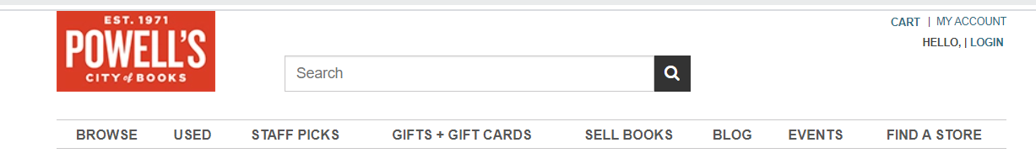

Requirement :

* Should have one logo image , when we click on logo should land on home page
* Main Navigation – Should follow page structure to show navigation and upto 2nd level page structure should be shown.
* Should have login component
* Should have Cart component

Acceptance Criteria:

* Should accommodate logo , cart, login , Main navigation.
* Should be added to template
* Once page created with header by using hat template.

**Footer**

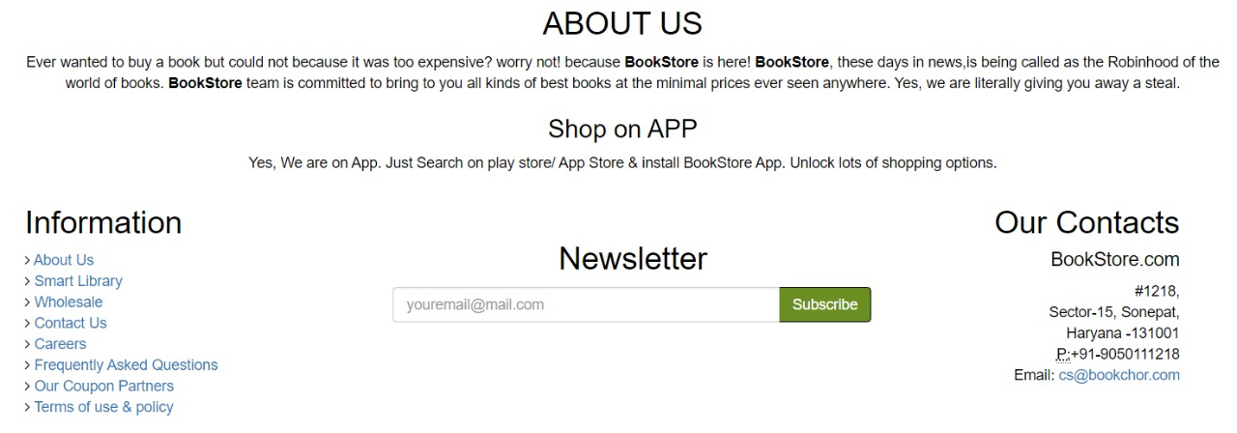

Requirement:

* Should have text component to author the content
* Should have information pages
* Should have address

Acceptance Criteria:

* Able to author it
* Able to include text , page information , newsletters component
* Should be included in template
* Once create page footer should be available.

**Main Navigation**

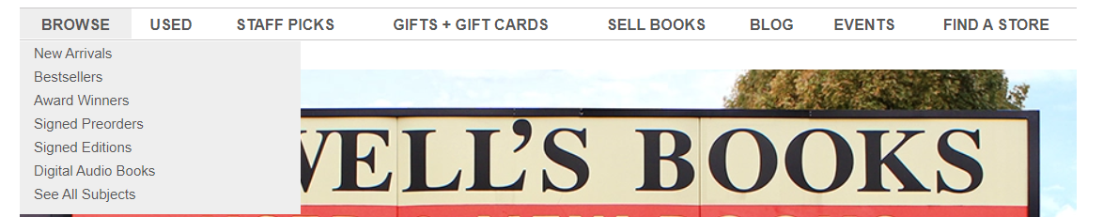

Requirement:

* Should be created according to page structure
* Should be shown two page level.
* Should navigated to corresponding page.

Acceptance Criteria:

* Once we click on pages should be land on corresponding page.
* Label should be pic from page title
* Should show two page levels in navigation
* Should be authorable

**Side Navigation**

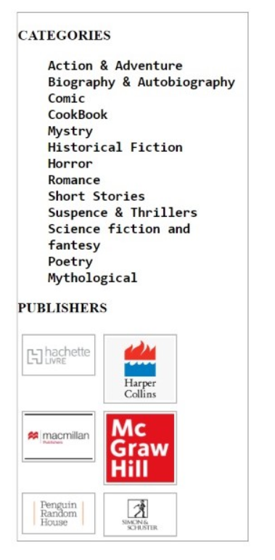

Requirement:

* Should be able show categories
* Should be able show Brands

Acceptance Criteria:

* Categories should be get it from DB as per Books data
* Once click on category should be filtered and should be able to see particular category books.
* Brands should be get it from DB as per Books data
* Once click on Brands should be filtered and should be able to see particular Brands books.
* Images should be match with brands available in DB and get displayed in side navigation.

**Carousel Component**

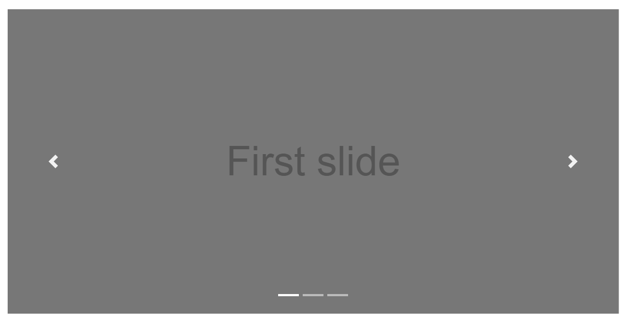

Requirement:

* Should be able to add slides
* Should be redirected to particular book detail page

Acceptance Criteria:

* Image and text can be authorable.
* Ability to add slides
* Ability add redirections.

**Product Tile**

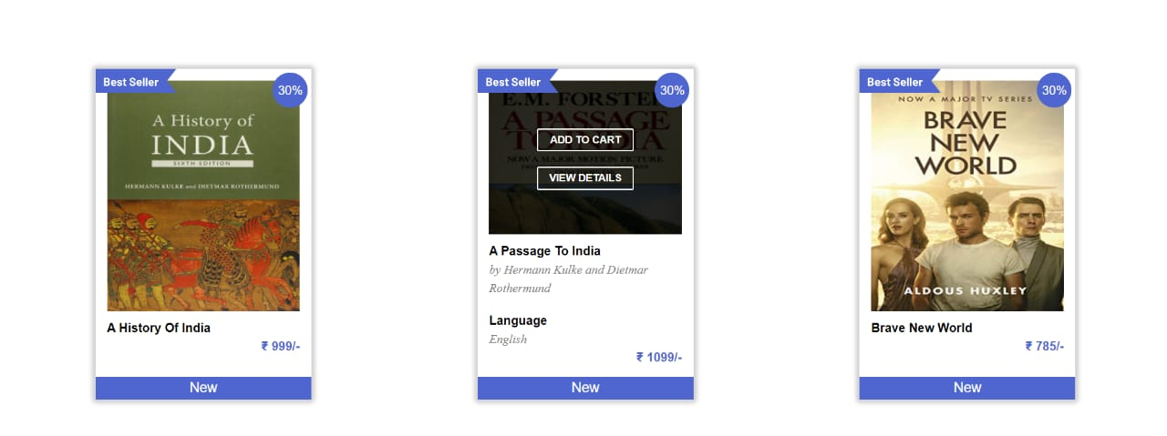

Requirement:

* Products page should have tiles.

Acceptance Criteria:

* Product tile should have Book image, title, price, description, author name, language.
* Should be fetch products information and should be shown on product page.
* Ability add to cart.
* Ability buy a book.
* Once click on tile, should be land on books details page.
* Images should be match with brands available in DB and get displayed in side navigation.

**Product Detail Component**

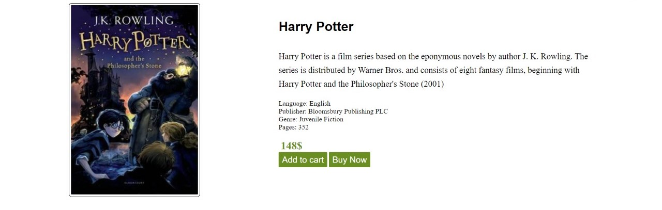

Requirement:

* Once click on tiles / view details on product should be land on product details page.

Acceptance Criteria:

* Should have product image.
* Should have description
* Category
* Author Name.
* Language
* Price
* Add to cart button
* Buy now option
* Page should be created on the fly.
* Publisher details.
* Ability buy / add multiple books.

**Banner**

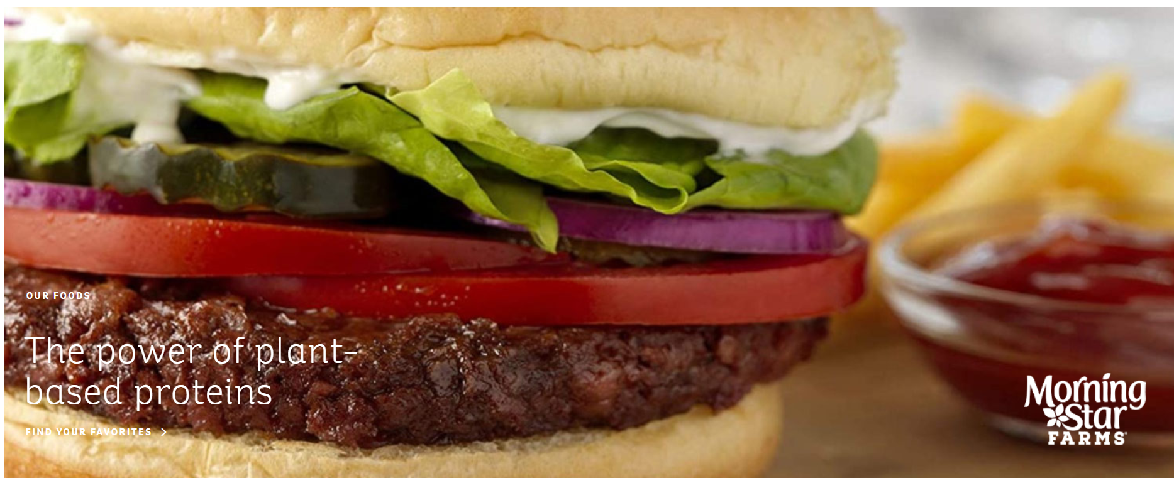

Requirement:

* Image and over lay text should be fit to page.

Acceptance Criteria:

* Image should be authorable
* Text can be authorable.
* Once click on banner, should be land on particular book details page.
* Ability to drag and drop on to the page.

**Image and Text**



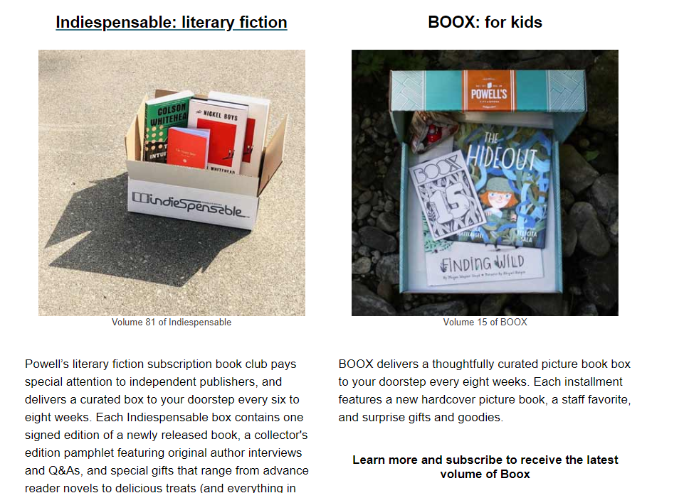

Requirement:

* Should have image and text component.

Acceptance Criteria:

* Image should be authorable.
* Text can be authorable.
* Format should be authors, ex: left side text and right side image, right side text and left side image.
* Format should be image with below text / text with below image.

**Column Control**



Requirement:

* Should have ability to have two , three column control to accommodate image and text component / text component / rich text component.

Acceptance Criteria:

* Should provide ability to drag and drop image and text , text , rich text components on to column control component.
* Should be authorable to have two columns / three columns.
* Should have ability to use on any page.

**Login**

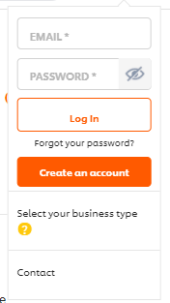

Requirement:

* Should have login component in header.

Acceptance Criteria:

* Able to login (once login should land on home page)
* If not able to login , should land on login page.

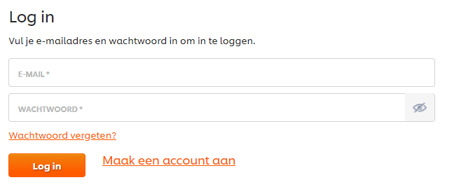

* Validations should be handles (front end and backend ) .
* Should have sign up ( should be land on sign up page)

**Problem statement 1 :**

**Image and Text**



Requirement:

* Should have image and text component.

Acceptance Criteria:

* Image should be authorable.
* Text can be authorable.
* Format should be authors, ex: left side text and right side image, right side text and left side image.
* Format should be image with below text / text with below image.

**Problem statement 2:**

**Login**



Requirement:

* Should have login component in header.

Acceptance Criteria:

* Able to login (once login should land on home page)
* If not able to login , should land on login page.

**Problem statement 3:**

**Banner**



Requirement:

* Image and over lay text should be fit to page.

Acceptance Criteria:

* Image should be authorable
* Text can be authorable.
* Once click on banner, should be land on particular book details page.
* Ability to drag and drop on to the page.

**Problem statement 4:**

**Carousel Component**



Requirement:

* Should be able to add slides
* Should be redirected to particular book detail page

Acceptance Criteria:

* Image and text can be authorable.
* Ability to add slides
* Ability add redirections.

**Problem statement 5:**

**Product Tile**



Requirement:

* Products page should have tiles.

Acceptance Criteria:

* Product tile should have Book image, title, price, description, author name, language.
* Should be fetch products information and should be shown on product page.
* Ability add to cart.
* Ability buy a book.
* Once click on tile, should be land on books details page.
* Images should be match with brands available in DB and get displayed in side navigation.

**Problem statement 6:**

**Header**



Requirement :

* Should have one logo image , when we click on logo should land on home page
* Main Navigation – Should follow page structure to show navigation and upto 2nd level page structure should be shown.
* Should have login component
* Should have Cart component

Acceptance Criteria:

* Should accommodate logo , cart, login , Main navigation.
* Should be added to template
* Once page created with header by using hat template.

**Problem statement 7:**

**Footer**



Requirement:

* Should have text component to author the content
* Should have information pages
* Should have address

Acceptance Criteria:

* Able to author it
* Able to include text , page information , newsletters component
* Should be included in template
* Once create page footer should be available.